# Computer Programming Lab 2

**Nabeel Ali BEE173059 Section-3 7-Match-2018**

//Activity 1

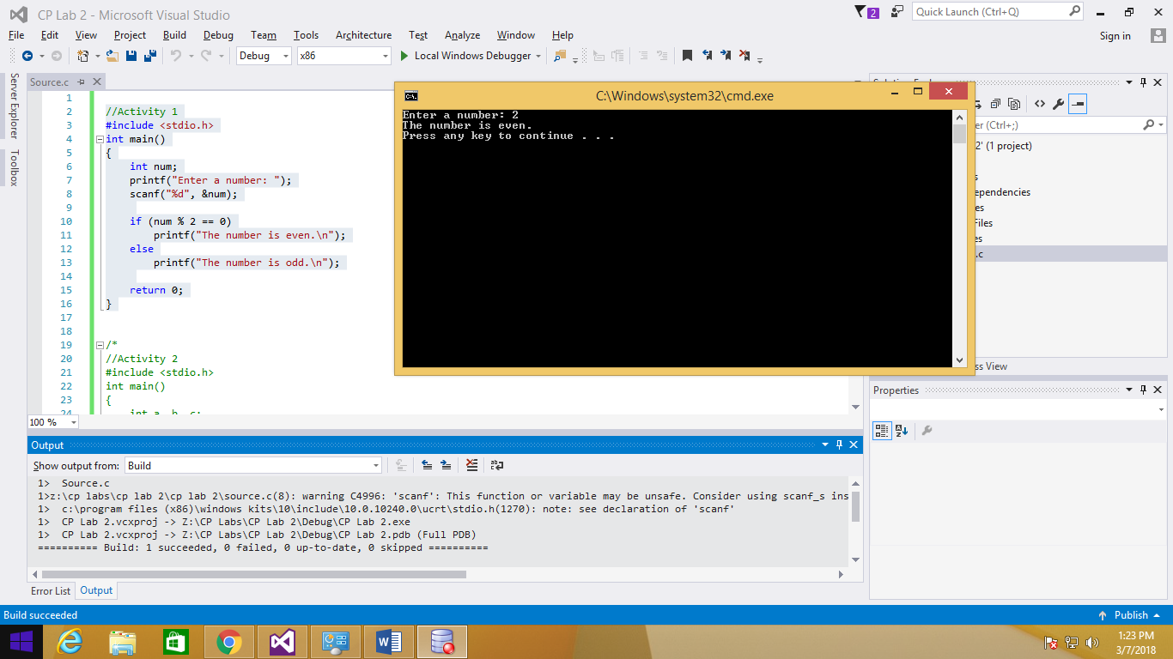#include <stdio.h>

int main()

{

int num;

printf("Enter a number: ");

scanf("%d", &num);

if (num % 2 == 0)

printf("The number is even.\n");

else

printf("The number is odd.\n");

return 0;

}

//Activity 2

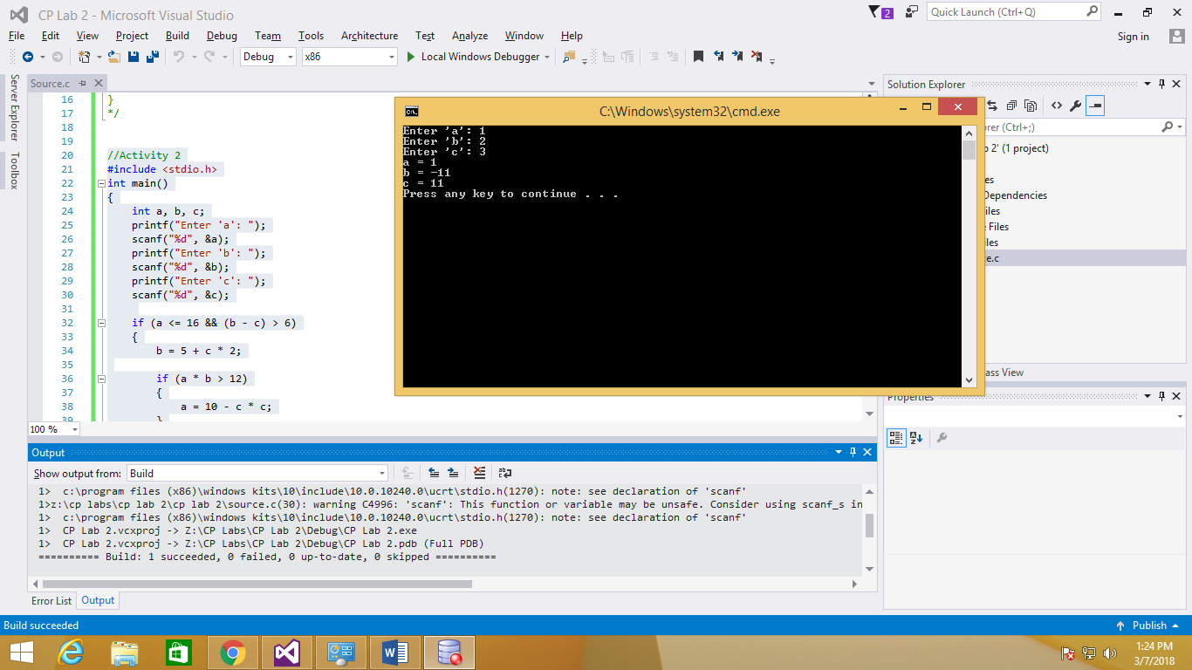#include <stdio.h>

int main()

{

int a, b, c;

printf("Enter 'a': ");

scanf("%d", &a);

printf("Enter 'b': ");

scanf("%d", &b);

printf("Enter 'c': ");

scanf("%d", &c);

if (a <= 16 && (b - c) > 6)

{

b = 5 + c * 2;

if (a * b > 12)

{

a = 10 - c * c;

}

}

else

{

if (c != b)

c = 5 + c * 2;

b = a * (-c);

}

printf("a = %d\nb = %d\nc = %d\n", a, b, c);

return 0;

}

//Activity 3

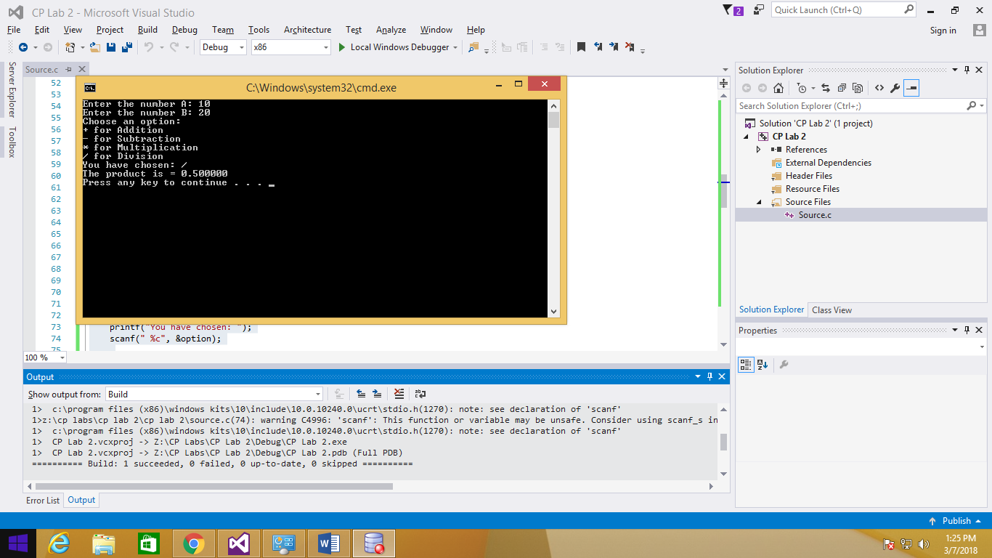#include <stdio.h>

int main()

{

int sum, difference, product;

float A, B, division;

char option;

printf("Enter the number A: ");

scanf("%f", &A);

printf("Enter the number B: ");

scanf("%f", &B);

printf("Choose an option: \n");

printf("+ for Addition\n");

printf("- for Subtraction\n");

printf("* for Multiplication\n");

printf("/ for Division\n");

printf("You have chosen: ");

scanf(" %c", &option);

switch (option)

{

case '+':

sum = A + B;

printf("The sum is = %d\n", sum);

break;

case '-':

difference = A - B;

printf("The difference is = %d\n", difference);

break;

case '*':

product = A * B;

printf("The product is = %d\n", product);

break;

case '/':

if (B == 0)

{

printf("Error: Dividing by zero.\n");

}

else

{

division = A / B;

printf("The product is = %f\n", division);

}

break;

default:

printf("You have entered the wrong input.\n");

}

return 0;

}

//Activity 4

#include <stdio.h>

int main()

{

int num1, num2, num3;

printf("Enter the 1st number: ");

scanf("%d", &num1);

printf("Enter the 2nd number: ");

scanf("%d", &num2);

printf("Enter the 3rd number: ");

scanf("%d", &num3);

if (num1 < num2)

{

if (num1 < num3)

{

printf("The smallest number is = %d.\n", num1);

}

else

{

printf("The smallest number is = %d.\n", num3);

}

}

else

{

if (num2 < num3)

{

printf("The smallest number is = %d.\n", num2);

}

else

{

printf("The smallest number is = %d.\n", num3);

}

}

return 0;

}

